EXAMPLE OF THE ABSTRACT FORMAT FOR THE 2022 BASIN AND RANGE EARTHQUAKE SUMMIT (BRES), SALT LAKE CITY, UTAH

Borah F. Peak, Lost River University, bpeak@lru.edu
Monte F. Cristo, Western Nevada College, mfcristo@western.edu
Author name, affiliation, email address

Abstract

Enter abstract text here. Please ensure your abstract is not over 2,500 characters in length, without spaces. Lorem Ipsum is simply dummy text of the printing and typesetting industry. Lorem Ipsum has been the industry's standard dummy text ever since the 1500s, when an unknown printer took a galley of type and scrambled it to make a type specimen book. It has survived not only five centuries, but also the leap into electronic typesetting, remaining essentially unchanged. It was popularized in the 1960s with the release of Letraset sheets containing Lorem Ipsum passages, and more recently with desktop publishing software like Aldus PageMaker including versions of Lorem Ipsum. Lorem Ipsum is simply dummy text of the printing and typesetting industry. Lorem Ipsum has been the industry's standard dummy text ever since the 1500s, when an unknown printer took a galley of type and scrambled it to make a type specimen book. It has survived not only five centuries, but also the leap into electronic typesetting, remaining essentially unchanged. It was popularized in the 1960s with the release of Letraset sheets containing Lorem Ipsum passages, and more recently with desktop publishing software like Aldus PageMaker including versions of Lorem Ipsum. Lorem Ipsum is simply dummy text of the printing and typesetting industry. Lorem Ipsum has been the industry's standard dummy text ever since the 1500s, when an unknown printer took a galley of type and scrambled it to make a type specimen book. It has survived not only five centuries, but also the leap into electronic typesetting, remaining essentially unchanged. It was popularized in the 1960s with the release of Letraset sheets containing Lorem Ipsum passages, and more recently with desktop publishing software like Aldus PageMaker including versions of Lorem Ipsum. Lorem Ipsum is simply dummy text of the printing and typesetting industry. Lorem Ipsum has been the industry's standard dummy text ever since the 1500s, when an unknown printer took a galley of type and scrambled it to make a type specimen book. It has survived not only five centuries, but also the leap into electronic typesetting, remaining essentially unchanged. It was popularized in the 1960s with the release of Letraset sheets containing Lorem Ipsum passages, and more recently with desktop publishing software like Aldus PageMaker including versions of Lorem Ipsum.

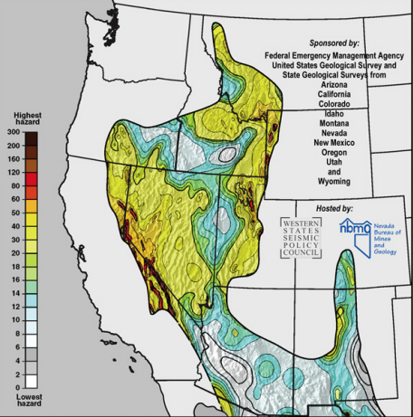
Figure 1. Figure caption text here. You can include up to one figure or table.

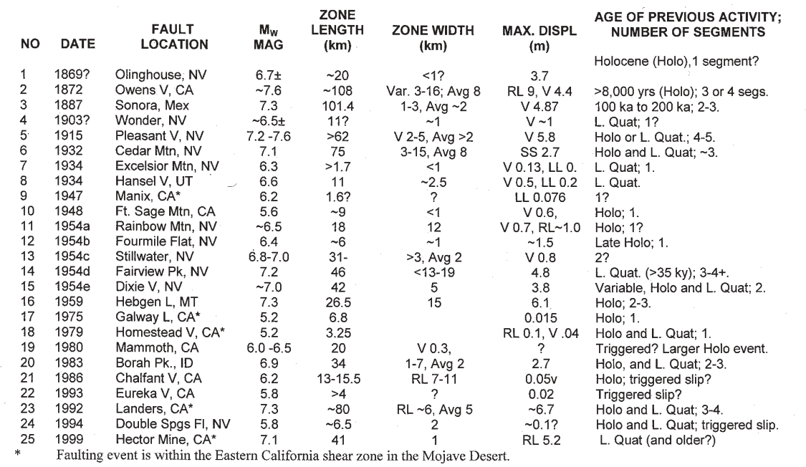
Table 1. Table caption text here.

